***Jobbing***

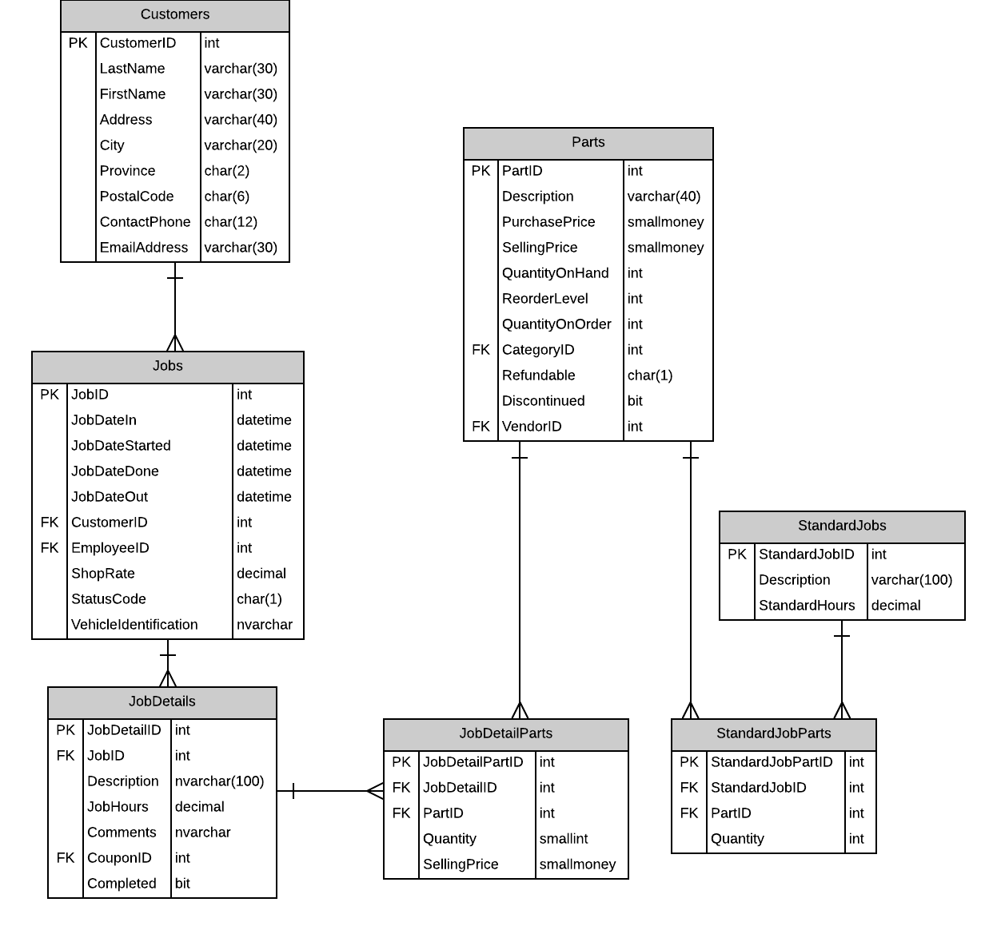

# Possible UX Interface

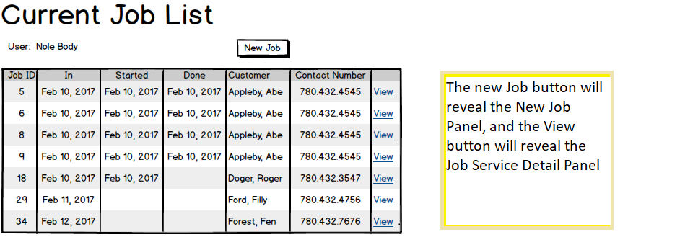

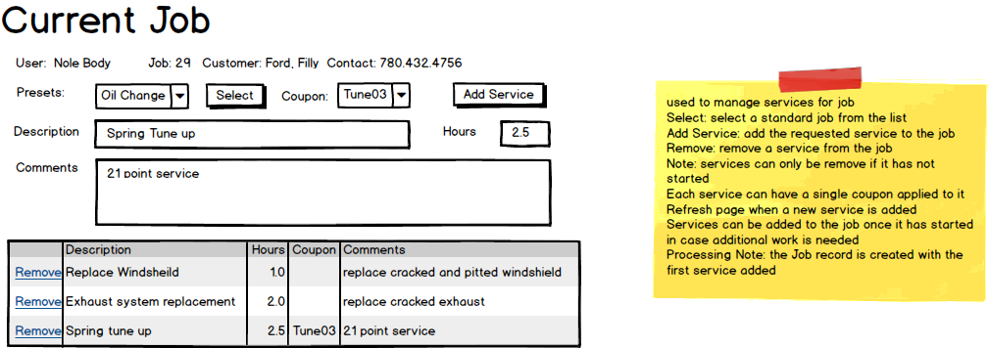

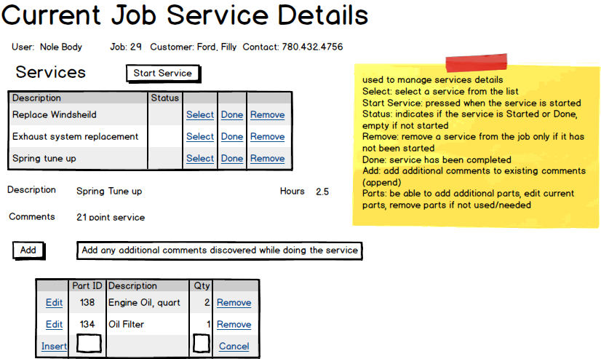

# Summation and wiring

**Current Jobs**

|  |  |  |
| --- | --- | --- |
| **Controls** | | **Events** |
| JobList(gridview) | | None, wired via ods |
| **BBL Class(es) and Method (s)** | | |
| Job Controller | List<Jobs> Job_List()   * Will return the list of the currently active jobs | |
| **SQL Table(s): (C,R,U,D)** | | **Entities/DTOs/POCOs** |
| Jobs (R) | | Job entity |

|  |  |  |
| --- | --- | --- |
| **Controls** | | **Events** |
| NewJob(button) | | OnClick   * Current job list hides * Panel 1(new job processing) visible, panel 2 hidden(service processing) |
| **BBL Class(es) and Method (s)** | | |
| Jobs controller | Add_Job()   * Will show the new job creation form * Will be used to add jobs to the active job list | |
| **SQL Table(s): (C,R,U,D)** | | **Entities/DTOs/POCOs** |
| JobDetails(R) | | JobDetail Entity |

|  |  |  |
| --- | --- | --- |
| **Controls** | | **Events** |
| View button on Gridview | | OnClick   * Hides the New job process panel * Shows the Service Processing panel |
| **BBL Class(es) and Method (s)** | | |
| JobDetailController | List<JobDetail>ViewJobDetail()   * Will return a list of job services for a currently active job | |
| **SQL Table(s): (C,R,U,D)** | | **Entities/DTOs/POCOs** |
| JobDetail(R) | | JobDetail entity |

**View/Edit on Current Job**

|  |  |  |
| --- | --- | --- |
| **Controls** | | **Events** |
| Labels:   * Job number * Customer name * Customer contact number * Coupon * Description * Comments * hours | | None |
| **BBL Class(es) and Method (s)** | | |
| CustomerController  JobDetailController | Void Customer_Get(JobID)   * Display the customer information   Void JobDetails_Get(JobID)  Display Service information | |
| **SQL Table(s): (C,R,U,D)** | | **Entities/DTOs/POCOs** |
| Customers(R), JobDetail(R) | | Customer (E), JobDetail(E) |

|  |  |  |
| --- | --- | --- |
| **Controls** | | **Events** |
| StandardJobsDDL | | None / wired via ObjectDataSource |
| **BBL Class(es) and Method (s)** | | |
| JobsDetailController | List<JobDetails> StandardJob_Get()   * Will return the list of available standard jobs into the DDL | |
| **SQL Table(s): (C,R,U,D)** | | **Entities/DTOs/POCOs** |
| JobDetails(R) | | JobDetail entity |

|  |  |  |
| --- | --- | --- |
| **Controls** | | **Events** |
| SelectStandardJob button | | On Click   * Populates the empty fields with information related to the chosen Standard Job from DDL |
| **BBL Class(es) and Method (s)** | | |
| JobDetailController | void StandardJob_Get(JobID)   * To get the standard job details for the selected job | |
| **SQL Table(s): (C,R,U,D)** | | **Entities/DTOs/POCOs** |
| JobDetails(R) | | JobDetail entity |

|  |  |  |
| --- | --- | --- |
| **Controls** | | **Events** |
| CouponDDL | | None / wired via ObjectDataSource |
| **BBL Class(es) and Method (s)** | | |
| JobDetailController | List<JobDetail> Coupon_Get(), void Coupon_Add(CouponID)   * To retrieve a list of coupons and put into the DDL * Will add/change the selected CouponID to for the related Job | |
| **SQL Table(s): (C,R,U,D)** | | **Entities/DTOs/POCOs** |
| JobDetails(R,U) | | JobDetail entity |

|  |  |  |
| --- | --- | --- |
| **Controls** | | **Events** |
| AddService button | | OnClick   * A service will be added to the list of services for that job, * New Job will create |
| **BBL Class(es) and Method (s)** | | |
| JobDetailController, JobController | Void AddService(JobID, CouponID)   * Will add a service to a customer – used in the JobDetailController   Void AddJob(JobID, Cutomer info)   * Will add a job to the Current job list once a service is added | |
| **SQL Table(s): (C,R,U,D)** | | **Entities/DTOs/POCOs** |
| Customer(R), JobDetails(C,U), Jobs(C,U) | | JobDetail(E), Jobs(E) |

|  |  |  |
| --- | --- | --- |
| **Controls** | | **Events** |
| Display Services(ListView) | | None / wired via ObjectDataSource |
| **BBL Class(es) and Method (s)** | | |
| JobDetailController | List<JobDetail> List_JobDetail()   * Returns a list of services for a job | |
| **SQL Table(s): (C,R,U,D)** | | **Entities/DTOs/POCOs** |
| JobDetails(R) | | JobDetail(E) |

|  |  |  |
| --- | --- | --- |
| **Controls** | | **Events** |
| Remove Button | | OnClick   * Delete -removes the service from a job if it hasn’t started yet. |
| **BBL Class(es) and Method (s)** | | |
| JobDetailController | Void Service_Delete(item)   * Will remove the item from the service list | |
| **SQL Table(s): (C,R,U,D)** | | **Entities/DTOs/POCOs** |
| JobDetails(D) | | JobDetail(E) |

**View/Edit on Current Job Service**

|  |  |  |
| --- | --- | --- |
| **Controls** | | **Events** |
| Labels:   * Job number * Customer name * Customer contact number * Coupon * Description * Comments * hours | | None |
| **BBL Class(es) and Method (s)** | | |
| CustomerController  JobDetailController | Void Customer_Get(JobID)   * Display the customer information   Void JobDetails_Get(JobID)   * Display Service information | |
| **SQL Table(s): (C,R,U,D)** | | **Entities/DTOs/POCOs** |
| Customers(R), JobDetails(R), StandardJobs(R) | | Customer (E), JobDetail(E) |

|  |  |  |
| --- | --- | --- |
| **Controls** | | **Events** |
| Display Services info (ListView) | | None/ODS |
| **BBL Class(es) and Method (s)** | | |
| JobDetailController | List<JobDetail> List_JobDetail()   * Returns a list of services for a job | |
| **SQL Table(s): (C,R,U,D)** | | **Entities/DTOs/POCOs** |
| JobDetails(D) | | JobDetail(E) |

|  |  |  |
| --- | --- | --- |
| **Controls** | | **Events** |
| Start Service Button | | OnClick   * Change the flag to checked and change status to Started |
| **BBL Class(es) and Method (s)** | | |
| JobDetailController | Void Job_Started(JobID)   * Will pass in the job id and change the flag to Started(true) and set the date | |
| **SQL Table(s): (C,R,U,D)** | | **Entities/DTOs/POCOs** |
| JobDetails(U) | | JobDetail(E) |

|  |  |  |
| --- | --- | --- |
| **Controls** | | **Events** |
| Select | | OnClick   * Select the Service * Populate parts needed for service into the Parts Listview |
| **BBL Class(es) and Method (s)** | | |
| JobPartsController | List<Parts> Parts_Get(JobID)   * Will pass the JobID and return a list of Parts used for that service | |
| **SQL Table(s): (C,R,U,D)** | | **Entities/DTOs/POCOs** |
| JobDetailsParts(R) | | JobDetailParts(E) |

|  |  |  |
| --- | --- | --- |
| **Controls** | | **Events** |
| Done | | OnClick   * Changes the flag on active to false (Done) |
| **BBL Class(es) and Method (s)** | | |
| JobDetailController | Void Job_Done(JobID)   * Will pass in the job id and change the flag to Done(false) and set the date | |
| **SQL Table(s): (C,R,U,D)** | | **Entities/DTOs/POCOs** |
| JobDetails(U) | | JobDetail(E) |

|  |  |  |
| --- | --- | --- |
| **Controls** | | **Events** |
| Select | | OnClick   * Select the Service * Populate parts needed for service into the Parts Listview |
| **BBL Class(es) and Method (s)** | | |
| JobPartsController | List<Parts> Parts_Get(JobID)   * Will pass the JobID and return a list of Parts used for that service | |
| **SQL Table(s): (C,R,U,D)** | | **Entities/DTOs/POCOs** |
| JobDetailsParts(R) | | Part(E) |

|  |  |  |
| --- | --- | --- |
| **Controls** | | **Events** |
| Remove Button | | OnClick   * Delete -removes the service from a job if it hasn’t started yet. |
| **BBL Class(es) and Method (s)** | | |
| JobDetailController | Void Service_Delete(item)   * Will remove the item from the service list | |
| **SQL Table(s): (C,R,U,D)** | | **Entities/DTOs/POCOs** |
| JobDetails(D) | | Parts(E) |

|  |  |  |
| --- | --- | --- |
| **Controls** | | **Events** |
| Add Comment Button | | OnClick   * Adds a comment to the Selected service |
| **BBL Class(es) and Method (s)** | | |
| JobDetailController | Void Comment_Add(JobID, comment)   * Will be passed the job id and the comment to be placed on the textbox for the comment | |
| **SQL Table(s): (C,R,U,D)** | | **Entities/DTOs/POCOs** |
| JobDetails(C,U) | | JobDetail(E) |

|  |  |  |
| --- | --- | --- |
| **Controls** | | **Events** |
| Parts Needed ListView | | None/ODS |
| **BBL Class(es) and Method (s)** | | |
| PartsController | List<Parts> Parts_Get(JobID)   * Will pass the JobID and return a list of Parts used for that service | |
| **SQL Table(s): (C,R,U,D)** | | **Entities/DTOs/POCOs** |
| JobDetailsParts(R) | | Part(E) |

|  |  |  |
| --- | --- | --- |
| **Controls** | | **Events** |
| Edit on listview | | OnClick   * Lets the user change the quantity and description fields for the service for a certain job |
| **BBL Class(es) and Method (s)** | | |
| PartsController | Void Parts_Update(item)   * Will be passed an item to process the update of existing value | |
| **SQL Table(s): (C,R,U,D)** | | **Entities/DTOs/POCOs** |
| JobDetailsParts(U) | | Part(E) |

|  |  |  |
| --- | --- | --- |
| **Controls** | | **Events** |
| remove on listview | | OnClick   * Lets the user remove a part |
| **BBL Class(es) and Method (s)** | | |
| PartsController | Void Parts_Delete(item)   * Will be passed an item to process the deletion of a part on the list of parts needed for a service | |
| **SQL Table(s): (C,R,U,D)** | | **Entities/DTOs/POCOs** |
| JobDetailsParts(D) | | Part(E) |

|  |  |  |
| --- | --- | --- |
| **Controls** | | **Events** |
| Insert on listview | | OnClick   * Lets the user insert a part |
| **BBL Class(es) and Method (s)** | | |
| PartsController | Void Parts_Add(item)   * Will be passed an item to process the addition of a part on the list of parts needed for a service | |
| **SQL Table(s): (C,R,U,D)** | | **Entities/DTOs/POCOs** |
| JobDetailsParts(D) | | Part(E) |